**AWS Block Storage Contd..**

**Activity: Create ubuntu linux server**

* Create an ubuntu linux server
* install apache2 and enable apache

sudo apt update

sudo apt install apache2 -y

sudo systemctl enable apache2

* Shutdown the ec2 instance
* Create the AMI  
  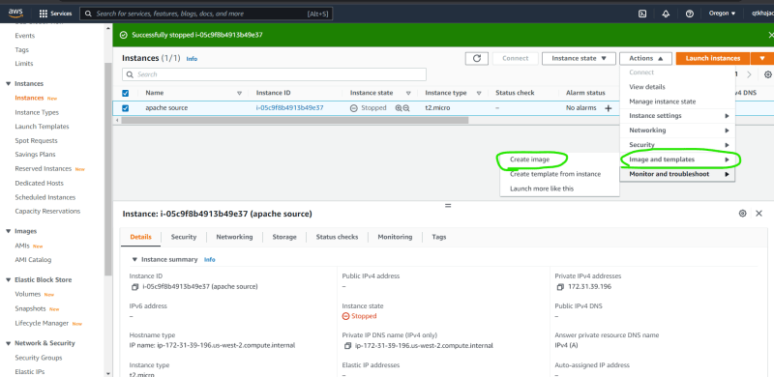  
  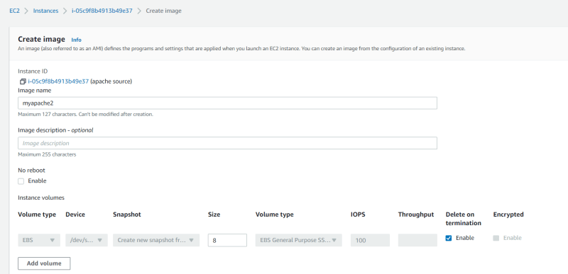  
  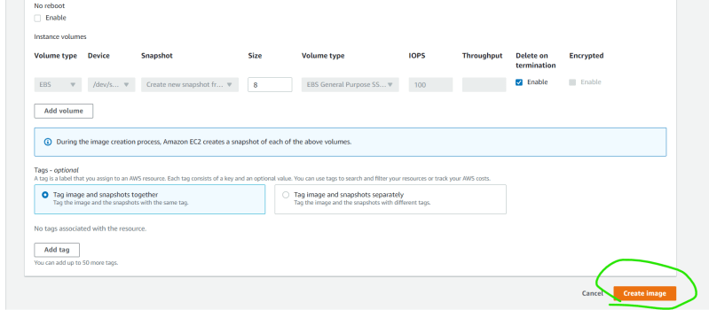  
  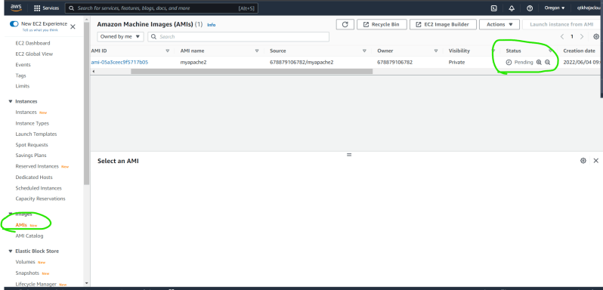  
  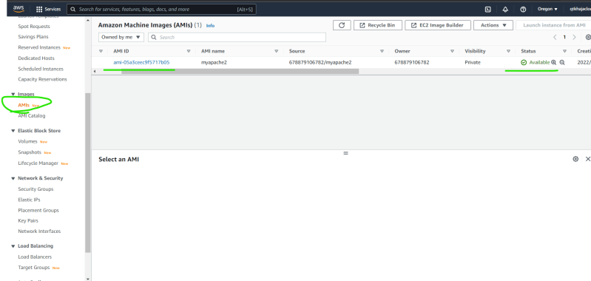
* The image (AMI) will be created and also a snapshot  
  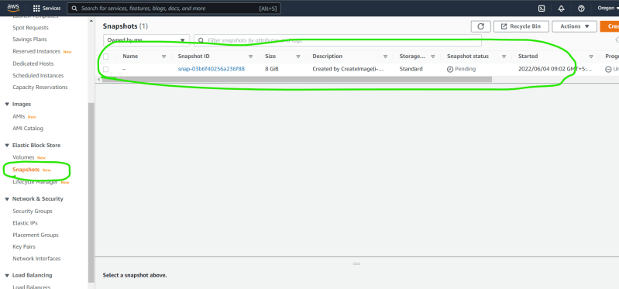  
  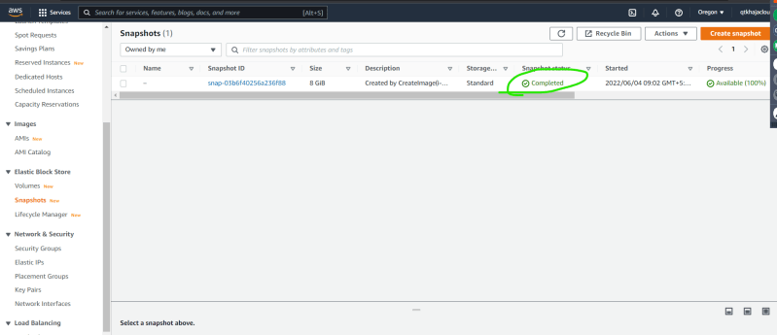
* now terminate the ec2 instance and create a new ec2 instance with the AMI Created.  
  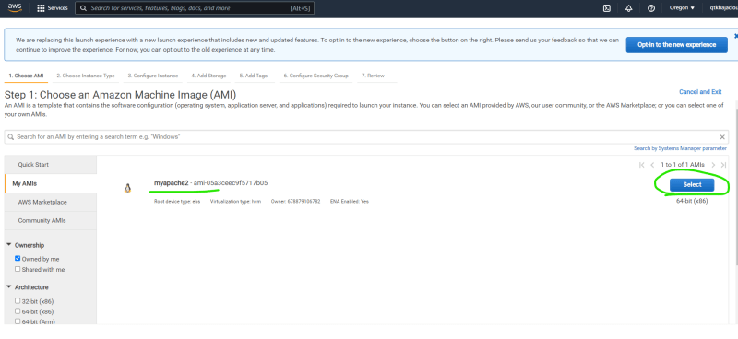  
  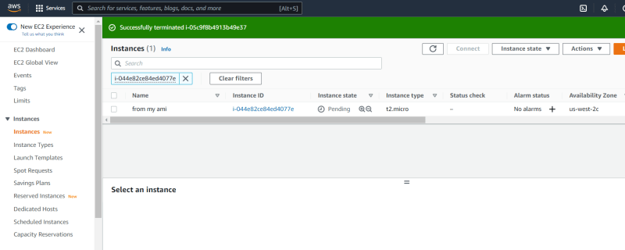  
  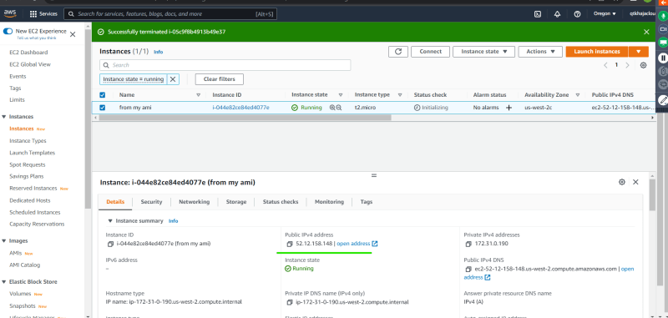  
  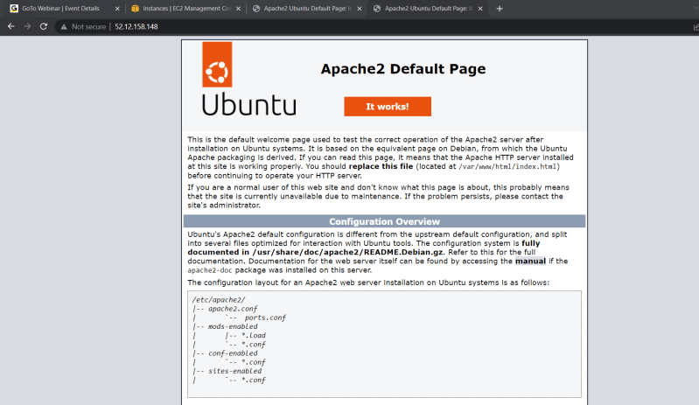
* This AMI can be copied to any region, the snapshot and AMI gets transferred and we can use this application in any aws region  
  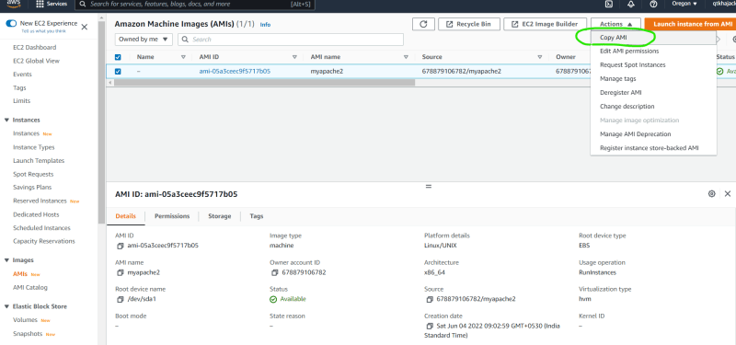  
  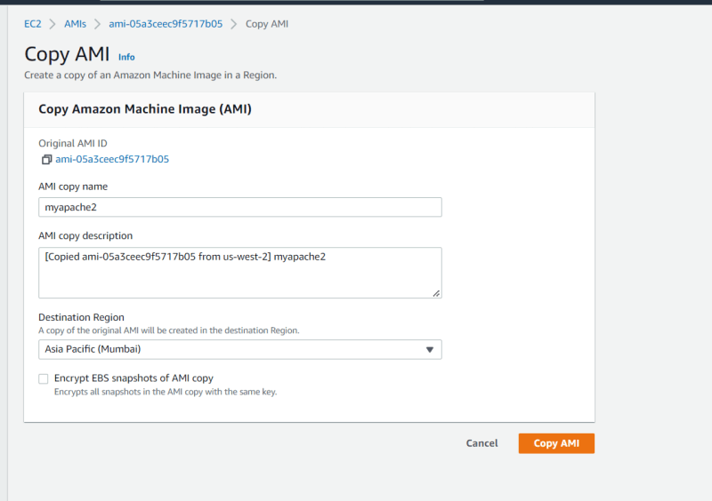
* To share this AMI with any of your other organizational accounts  
  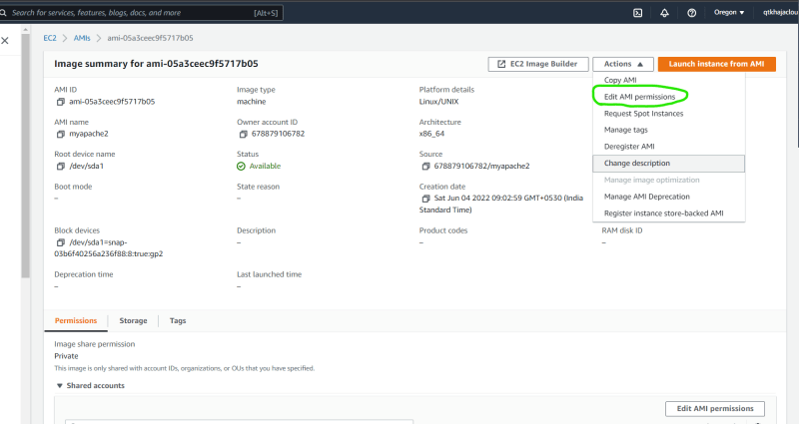  
  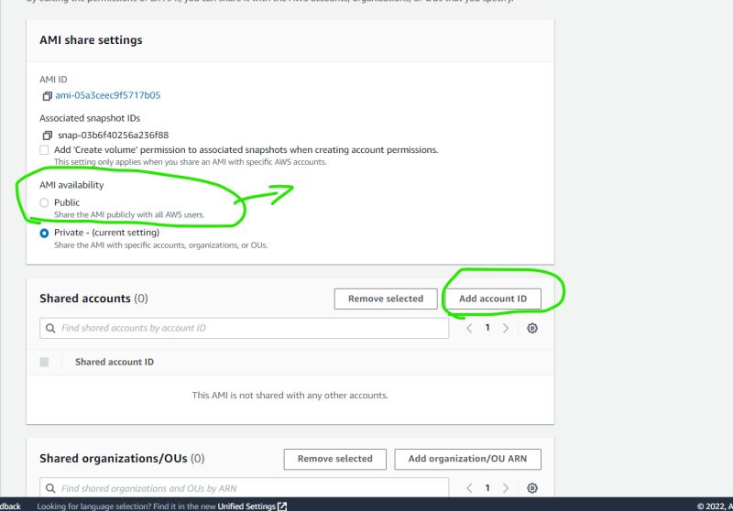

**File Shares**

* The EBS volumes can be attached to only one instance at a time, but generally in our application configurations, we would have some data/application etc which are required to be shared by multiple ec2 instances.

**Activity: File Share on the Linux VMs**

* Create the following ubuntu vms
  + in AZ-A
  + in AZ-B
* AWS has a network file storage service for linux based vm’s which is called as Elastic file storage
* Lets understand how efs works with the below image  
  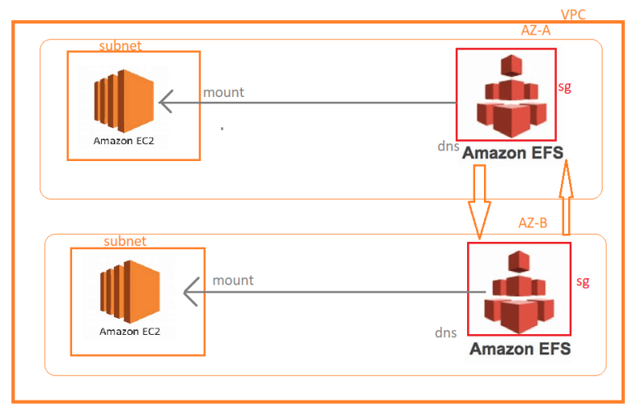
* Create a security group with access to vpc cidr  
  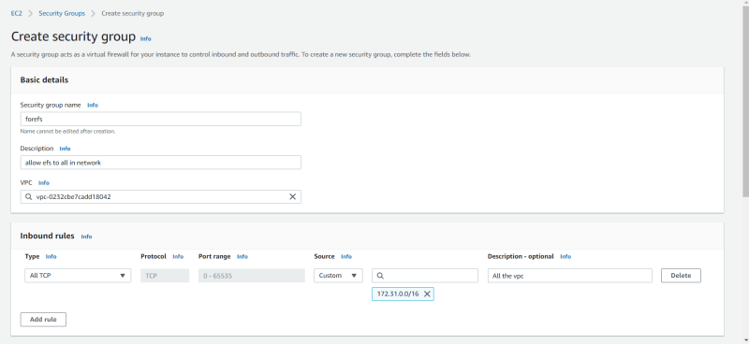
* Lets create EFS  
  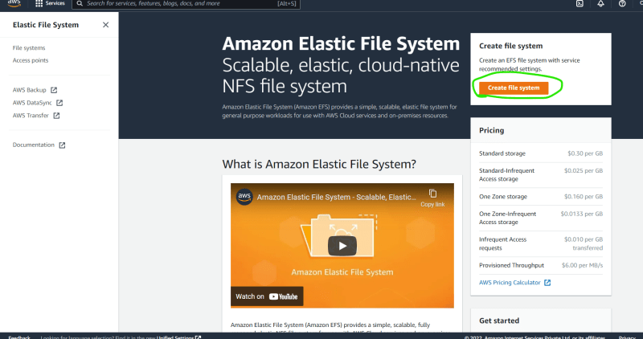  
  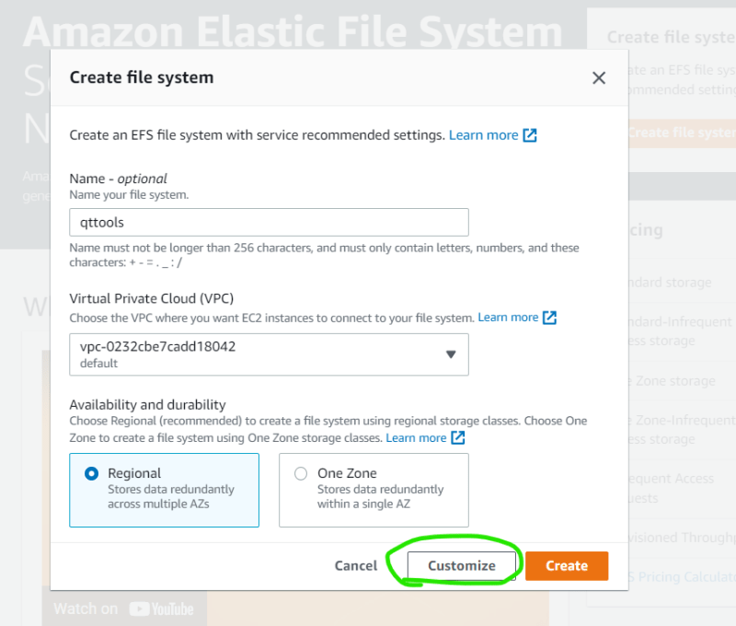  
  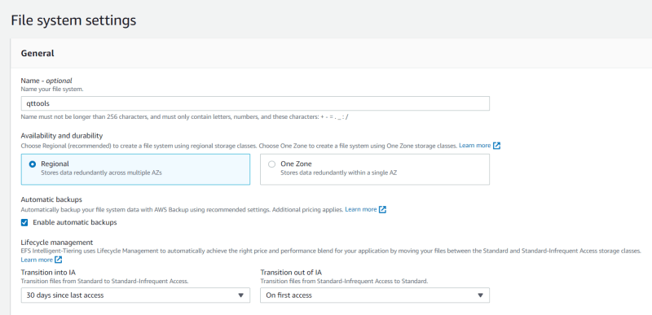  
  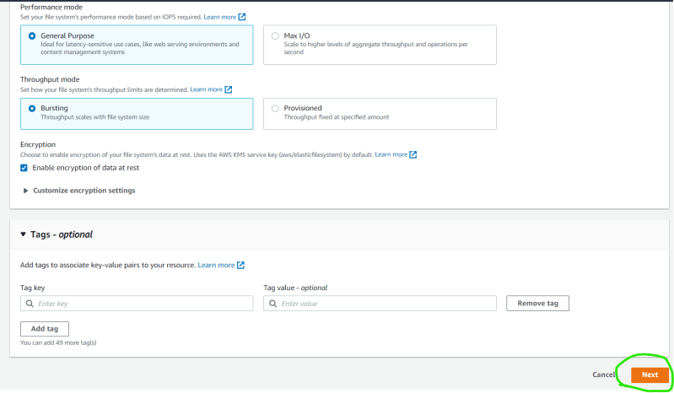  
  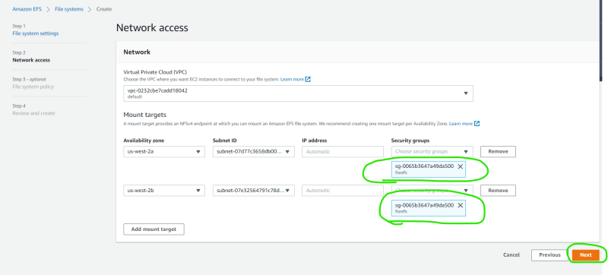  
  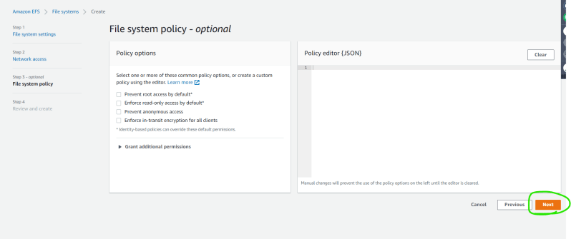  
  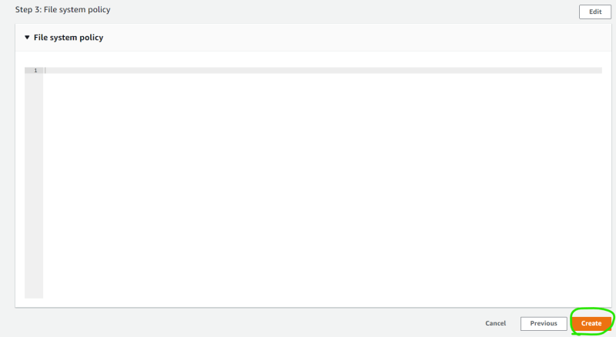  
  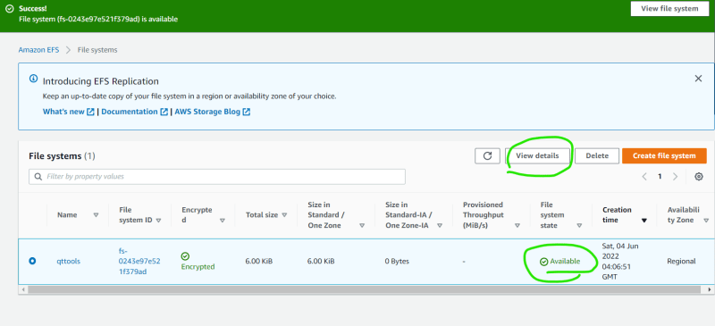
* Now lets understand on how to attach efs to the vms  
  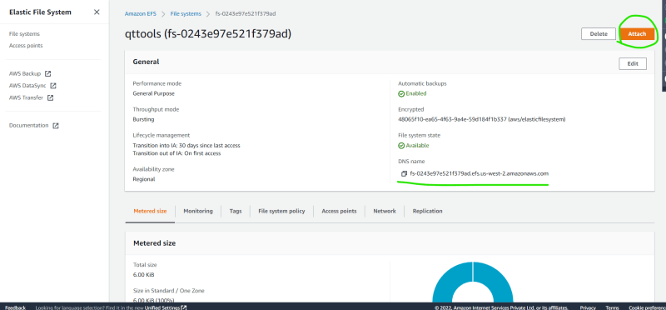  
  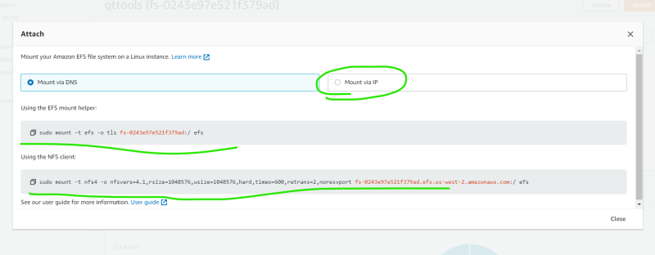
* [Refer Here](https://docs.aws.amazon.com/efs/latest/ug/mounting-fs.html) for understanding mounting steps
* Lets login into an ubuntu instance and mount. i had to install nfs common using the following command sudo apt install nfs-common -y  
  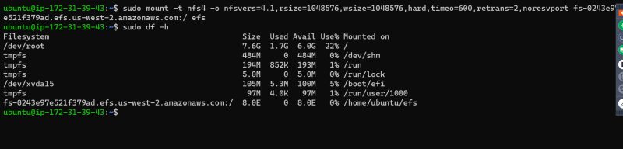  
  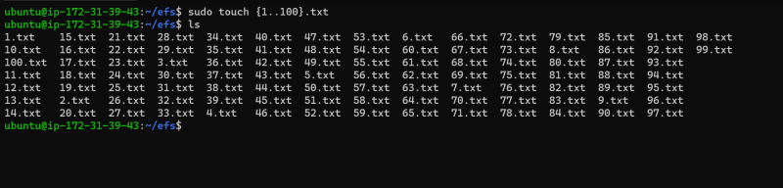
* Now lets login into other vm in other az (in my case amazon linux instance) sudo yum install amazon-efs-utils -y  
  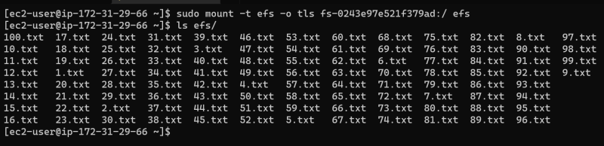  
  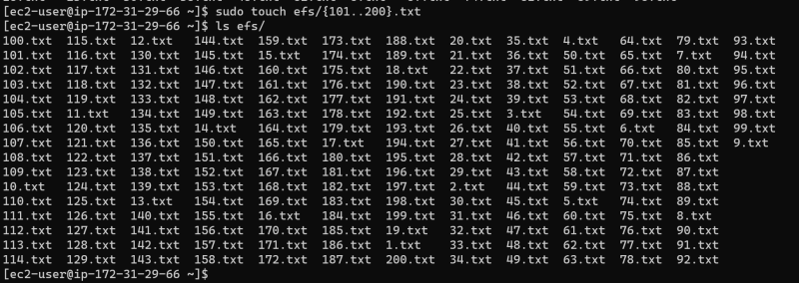
* EFS can act as a network file storage for linux and mac vms within a region in aws
* EFS is scoped to one region, but we can replicate the data to other regions as well  
  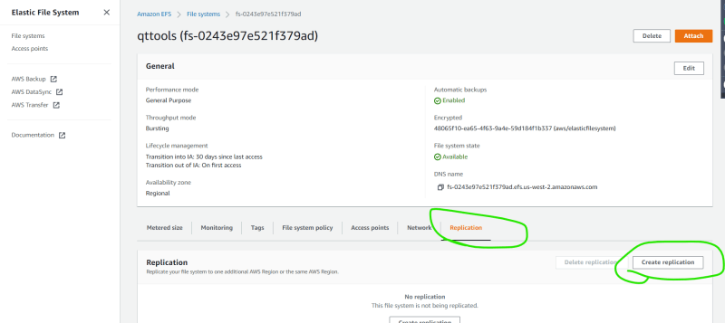  
  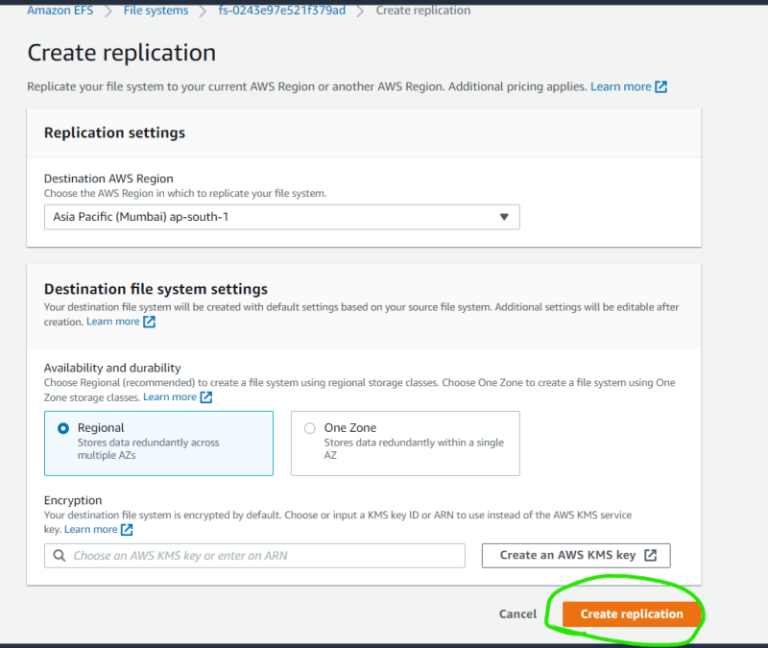
* EFS Backups can be managed by backup vaults.
* If we have windows ec2 instances, efs cant be used as a network share
* If we want to use third party storage options in a managed fashion, AWS provides FsX  
  